Requirement Analysis
Technology Stack (Architecture & Stack)
Date | 04 September 2026
Student Name | Pulibanti Tejavani
Project Name | Metro Ticket Generating System
Maximum Marks

Technical Architecture

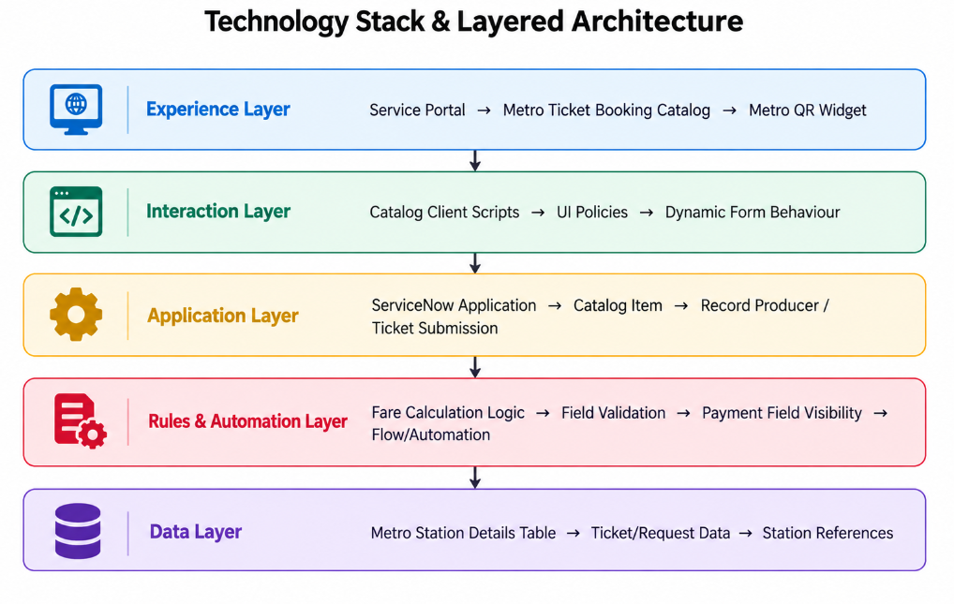
Figure 1: Layered technology architecture for the ServiceNow solution.

Technology Stack Table
S.No. | Component | Description | Technology
1 | User Interface | Passenger-facing metro ticket-booking interface | Service Portal
2 | Catalog | Provides the Book a Metro Ticket form and variables | Service Catalog / Catalog Item
3 | Application Logic | Handles ticket submission and record creation | ServiceNow Application / Record Producer
4 | Station Data | Stores available metro station names | Custom Metro Station Details Table
5 | Fare Calculation | Calculates fare according to route, journey type and passengers | Catalog Client Script
6 | Form Behaviour | Controls field visibility and dependent behaviour | UI Policies / Client Script
7 | QR Ticket | Displays the generated digital metro ticket QR code | Service Portal Widget / HTML
8 | Automation | Supports ticket processing and backend workflow | Flow Designer
9 | Security | Restricts access to backend metro data | ServiceNow ACLs
10 | Client Interaction | Provides dynamic form updates based on user selections | JavaScript / GlideForm

